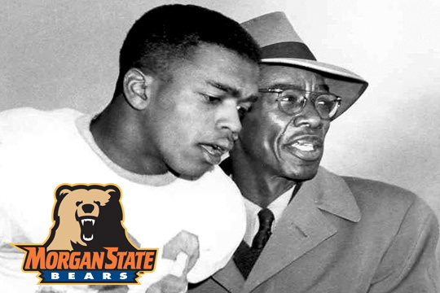
Legendary Morgan State coach Eddie P. Hurt
MSU Media Relations

10/21/2010 2:14:32 PM
Morgan State University’s football field is named after Earl C. Banks, and rightfully so. What Coach Banks was able to do for Morgan football still hasn’t been matched. He was a staple of the black college community in and out of Baltimore. But as we give Coach Banks all of the credit that he deserves, we are guilty of doing what we so often do in American history. We’ve forgotten the man who laid the foundation.
Eddie P. Hurt became Morgan’s football coach in 1929. The problem is, there aren’t too many folks still around who remember what Coach Hurt had to work with. He had to deal with an environment that did not recognize black college athletics at all. Coach Hurt and his assistant coach Talmadge L. Hill built an environment where young black men not only existed, but excelled. He did it by not only forming the blueprint, but laying the first brick.
In the eight years of Morgan football leading up to Coach Hurt, the program won a total of 22-games. Because no one new any better, no one really complained. Coach Hurt quickly changed that culture and raised people’s expectations.
Coach Hurt went on a run that laid the foundation that became Morgan Bear football. He went on to win 14 CIAA Championships 31 seasons. His career record of 171-54-18 was amazing. That’s an average of 6-2, basically.
From 1931-38 Coach Hurt led his team to an amazing 54-game winning streak. This isn’t even talked about today. Many young Bears fans may not even know this. To not know what Coach Hurt did for the Bears football program is to not know where this program started. It’s like a Dallas Cowboys fan not knowing who Tom Landry was. It’s unthinkable.
During Coach Hurt’s tenure, his teams were undefeated in 11 different seasons. In 1943, opponents failed to score a single point against the Bears. No wonder great defense is synonymous with the Bears.
Coach Hurt is a member of the HBCU football Hall of Fame, and maybe more should be done about one of the pioneers of black college football. Some would say Eddie Hurt paved the way for later success.
Coach Hurt left Morgan’s football program after the 1959 season He died 30-years later in 1989. Coach Hurt built Morgan State Football one relationship at a time.



Copyright © 2012 Morgan State Athletics
1700 East Cold Spring Lane, Baltimore MD 21251 | 443.885.3333 | All Rights Reserved.

8.31 | Men's Cross Country | Morgan State at Baltimore Metro Invitational | 9 a.m., Baltimore, Md. | Smooth Leads Bears with First Place Finish


